SpaceX Dragon demo capsule set to return to Earth

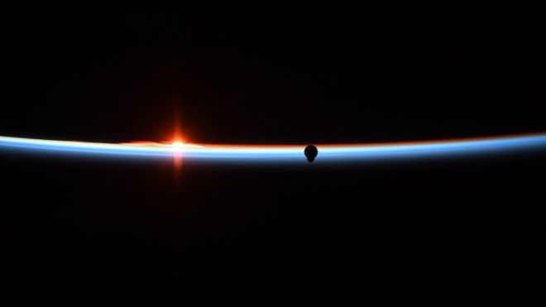
How the astronauts on the ISS saw the Dragon approach last weekend
America's new commercial astronaut capsule will complete its demonstration flight on Friday with a splashdown in the Atlantic Ocean.
The SpaceX Dragon vehicle will leave the International Space Station (ISS) where it's been docked this past week and drop through the atmosphere.
It has a heat-shield to protect it from the high temperatures of re-entry.
Four parachutes should bring it into soft contact with water about 450km from Cape Canaveral, Florida.
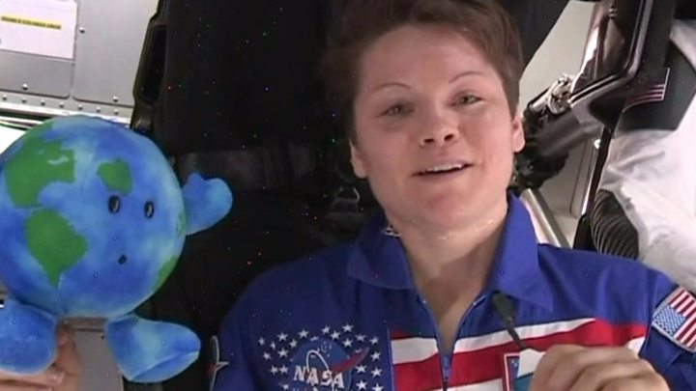
Splashdown is expected at about 08:45 EST (13:45 GMT). A boat, called GO Searcher, will be waiting to recover the capsule.

ISS astronaut Anne McClain went inside the Dragon capsule
The mission - which has no humans aboard, only a dummy covered in sensors - has gone according to the script so far.
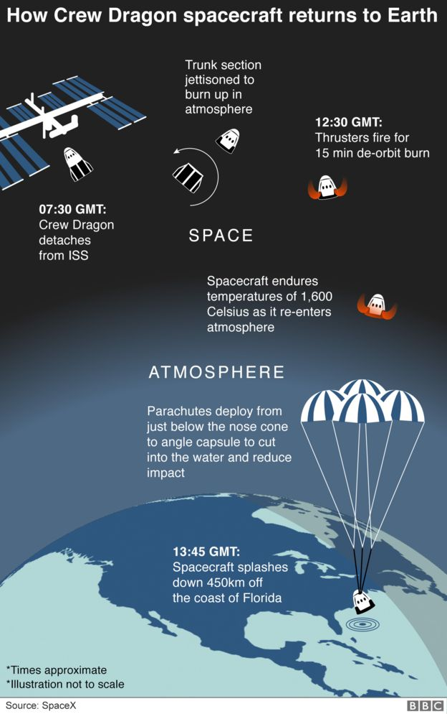
Assuming the Dragon performs equally well in the coming hours, it will set the stage for the US space agency (Nasa) to approve the vehicle for crewed flights.
The first of these could occur as soon as July, although no-one should be surprised if this target date slips into the summer as engineers work through the post-flight analysis.
For the Dragon's owner, SpaceX chief executive Elon Musk, there is still much to be accomplished on the existing mission, however.
He's expressed some anxiety about how the capsule will cope with re-entry.
The vehicle's backshell, or heatshield, has a somewhat irregular shape and this could lead to a roll instability at hypersonic speeds, he warns.
"I think it's unlikely; we've run simulations a thousand times but this is a possibility," the California-based entrepreneur told reporters at the weekend.
"So, re-entry with the asymmetric backshell; the parachutes are new - will the parachutes deploy correctly and then will the system guide Dragon to the right location and splashdown safely? I'd say hypersonic re-entry is my biggest concern."
Not since the shuttles has America been able to send its own astronauts into orbit. It's had to rely instead on Russia and its Soyuz spacecraft.
Nasa hopes to bring this near-eight-year gap in capability to an end with the introduction of two new commercial transportation systems.
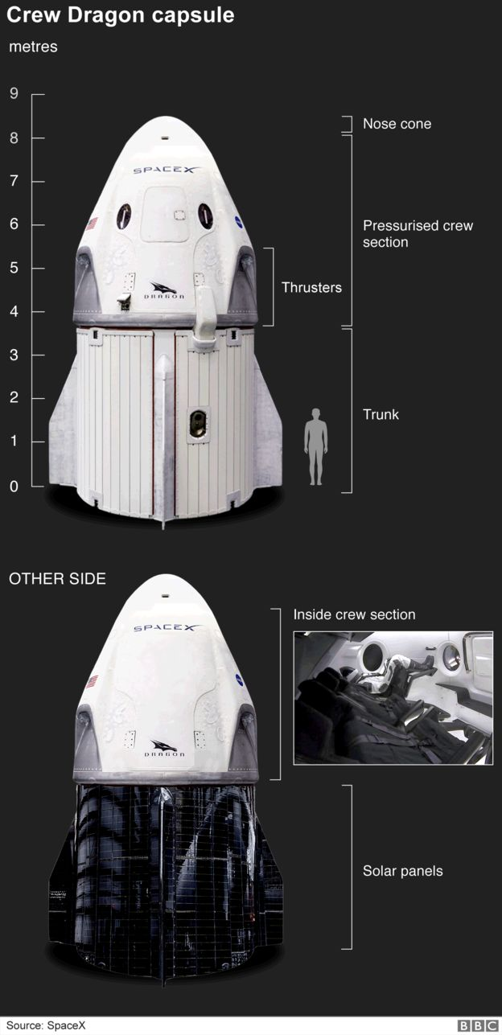
As well as SpaceX, the agency has seed-funded Boeing to produce a capsule of its own called the Starliner.
This vehicle is scheduled to have its uncrewed demonstration flight in April or soon after.
Ultimately, Nasa will be purchasing seats in both systems to take its astronauts to the ISS. But the commercial nature of the relationship means the companies will be free also to sell rides to secondary customers.
These will no doubt include the space agencies of other nations, but perhaps some private space companies and individuals too.
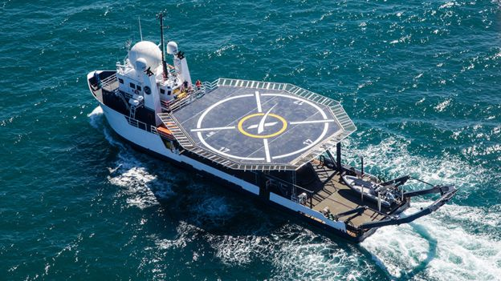
The GO Searcher vessel is tasked with picking Dragon crew capsules out of the water
Nasa has already selected its first astronauts to fly aboard a crewed Dragon.
Bob Behnken and Doug Hurley have been busy training with the SpaceX team, learning all about the capsule's operation and what to do if there is an emergency.
One problem that could occur is a failure of the Dragon's carrier rocket during the ascent to orbit.
The demonstration capsule's lift-off last Saturday was picture perfect, but some kind of booster anomaly can never be discounted.
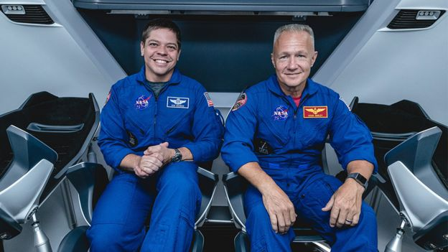
In such a scenario, a Dragon's powerful thrusters would push it away from the launcher to safety.

Behnken (L) and Doug Hurley (R) will be the first crew to ride a Dragon
SpaceX will practice this very procedure shortly.
The team plans to take the current Dragon after its return and put it on another rocket and launch it out of the Kennedy Space Center. A minute into this flight, a deliberate abort will be commanded.
The timing is significant because it's when the vehicle is experiencing maximum aerodynamic pressure.
If the Dragon can stably depart in such circumstances, it ought be able to handle an escape at any stage in a flight.
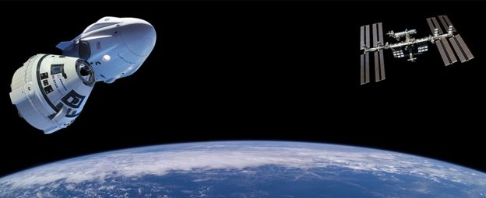
As with the present demo, no-one will be aboard for this hazardous test.
= Boeing (near) and SpaceX (far) have a commercial relationship with Nasa

